**Assignment on Exception Handling:**

1. **import** java.util.Scanner;

**public** **class** hello {

**public** **static** **void** main(String[] args) {

**int** i=9;

**int** j=0;

**try** {

**int** k= i/j;

System.***out***.print(k);

}

**catch**(Exception e){

System.***out***.println("Arithmetic Exception occurred");

}

}

}

**Output:**

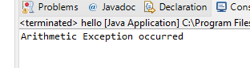

**3.a**

**import** java.util.Scanner;

**public** **class** hello {

**public** **static** **void** main(String[] args)

{

Scanner sc = **new** Scanner(System.***in***);

SavingAccount obj = **new** SavingAccount();

obj.id = 123;

obj.balance= 2000;

obj.deposit=500;

System.***out***.print("Enter The Amount: ");

obj.withdraw= sc.nextDouble();

**try** {

**if**(obj.withdraw> obj.balance || obj.balance==0)

{

**throw** **new** InsufficientBalanceException();

}

System.***out***.print("Wait for a moment !");

}

**catch**(Exception e){

System.***out***.println("Not enough balance for withdrawal");

}

}

}

**class** SavingAccount{

**long** id;

**double** balance;

**double** withdraw;

**double** deposit;

}

**Output:**

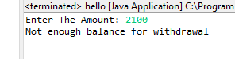

**3.b**

**import** java.util.Scanner;

**public** **class** hello {

**public** **static** **void** main(String[] args)

{

Scanner sc = **new** Scanner(System.***in***);

SavingAccount obj = **new** SavingAccount();

obj.id = 123;

obj.balance= 2000;

obj.deposit=500;

System.***out***.print("Enter The Amount: ");

obj.withdraw= sc.nextDouble();

**try** {

**if**(obj.withdraw> obj.balance || obj.balance==0)

{

**throw** **new** InsufficientBalanceException();

}

**else** **if**(obj.withdraw<0)

{

**throw** **new** IllegalBankTransactionException();

}

**else**

{

System.***out***.print("Wait for a moment !");

}

}

**catch**(IllegalBankTransactionException a)

{

System.***out***.println("You enterd a negative value...Try Again !!");

}

**catch**(Exception e){

System.***out***.println("Not enough balance for withdrawal");

}

}

}

**class** SavingAccount{

**long** id;

**double** balance;

**double** withdraw;

**double** deposit;

}

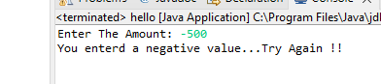

**Output:**